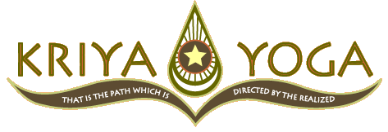

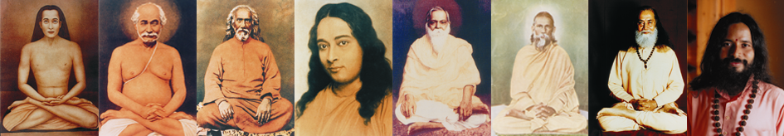

Kriya Yoga Meditation
Experience of the Divine

Lecture by

Yogacharya Claudia Cremers

a long term disciple and teacher authorised by Paramahamsa
Hariharananda and by Paramahamsa Prajnanananda, who is the current master in the lineage of the authentic Kriya Yoga.

Friday 18 March 2011, 19-21 H

YAOUNDE
Hotel Mansel (tel. 22202462)

Info: Joseph Tsomb (+237)77550119
Clovis Nguiessi (+33)632710508
Saturday 19 March, initiations 9-13 H,
Meditation & Technique Class 15.30-18.30 H
Sunday 20 March, Meditation, Class, Q&A 10.00-12.30 and 15-17 H

Intitiation costs 20.000 FCFA, participation weekend 15.000 FCFA (reduction possible)
www.kriya.asso.fr

