

● Friday August 22, 2025 7:00-9:00 pm The Scientific Teachings of Kriya Yoga Meditation (Love & Peace)
Free Public Lecture – All are Welcome
Location: Cincinnati Yoga School, 6125 Ridge Avenue, Cincinnati, OH 45213, 2nd Floor, Parking in rear of the building
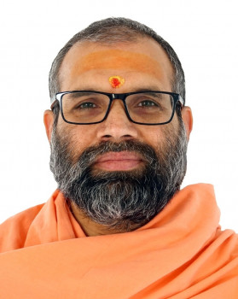
● Weekend Program Schedule for August 23 & 24, 2025 For those interested in Initiation, Reserve all Weekend Aug 23 & 24 Location: Kriya Yoga Center, 7005 Pinemill Drive, West Chester, OH 45069
Saturday, August 23, 2025 (Veg. Lunch Provided) 8:30 am to 12:30 pm Kriya Yoga Initiation Ceremony
2:00 pm to 5:00 pm Technique Class & Guided Meditation
Sunday, August 24, 2025 (Veg. Lunch Provided)
8:30 am to noon Technique Review & Guided Meditation
2:00 to 4:30 pm Q&A Session & Guided Meditatio
Swami Sahajananda Giri
One who rejoices in the joy of self, got initiated into Monasticism in 2016.

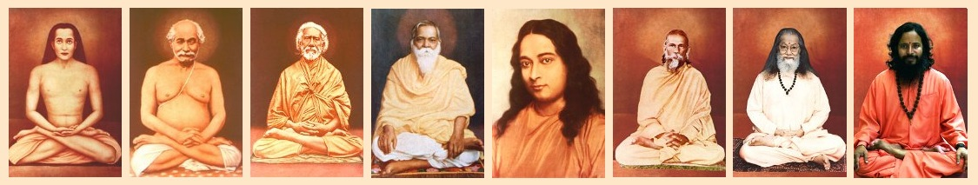
Kriya Yoga Institute - PO Box 924615 - Homestead FL 33092-46150
Phone +1 305-247-1960 email institute@kriya.org website www.kriya.org
Contact: Chanchal K Ghosh
Phone: 513-720-6840
Email: Cincinnati-OH@ kriya.org
https://www.kriya.org/online-registration/7846/en

