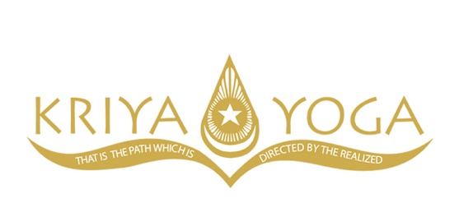
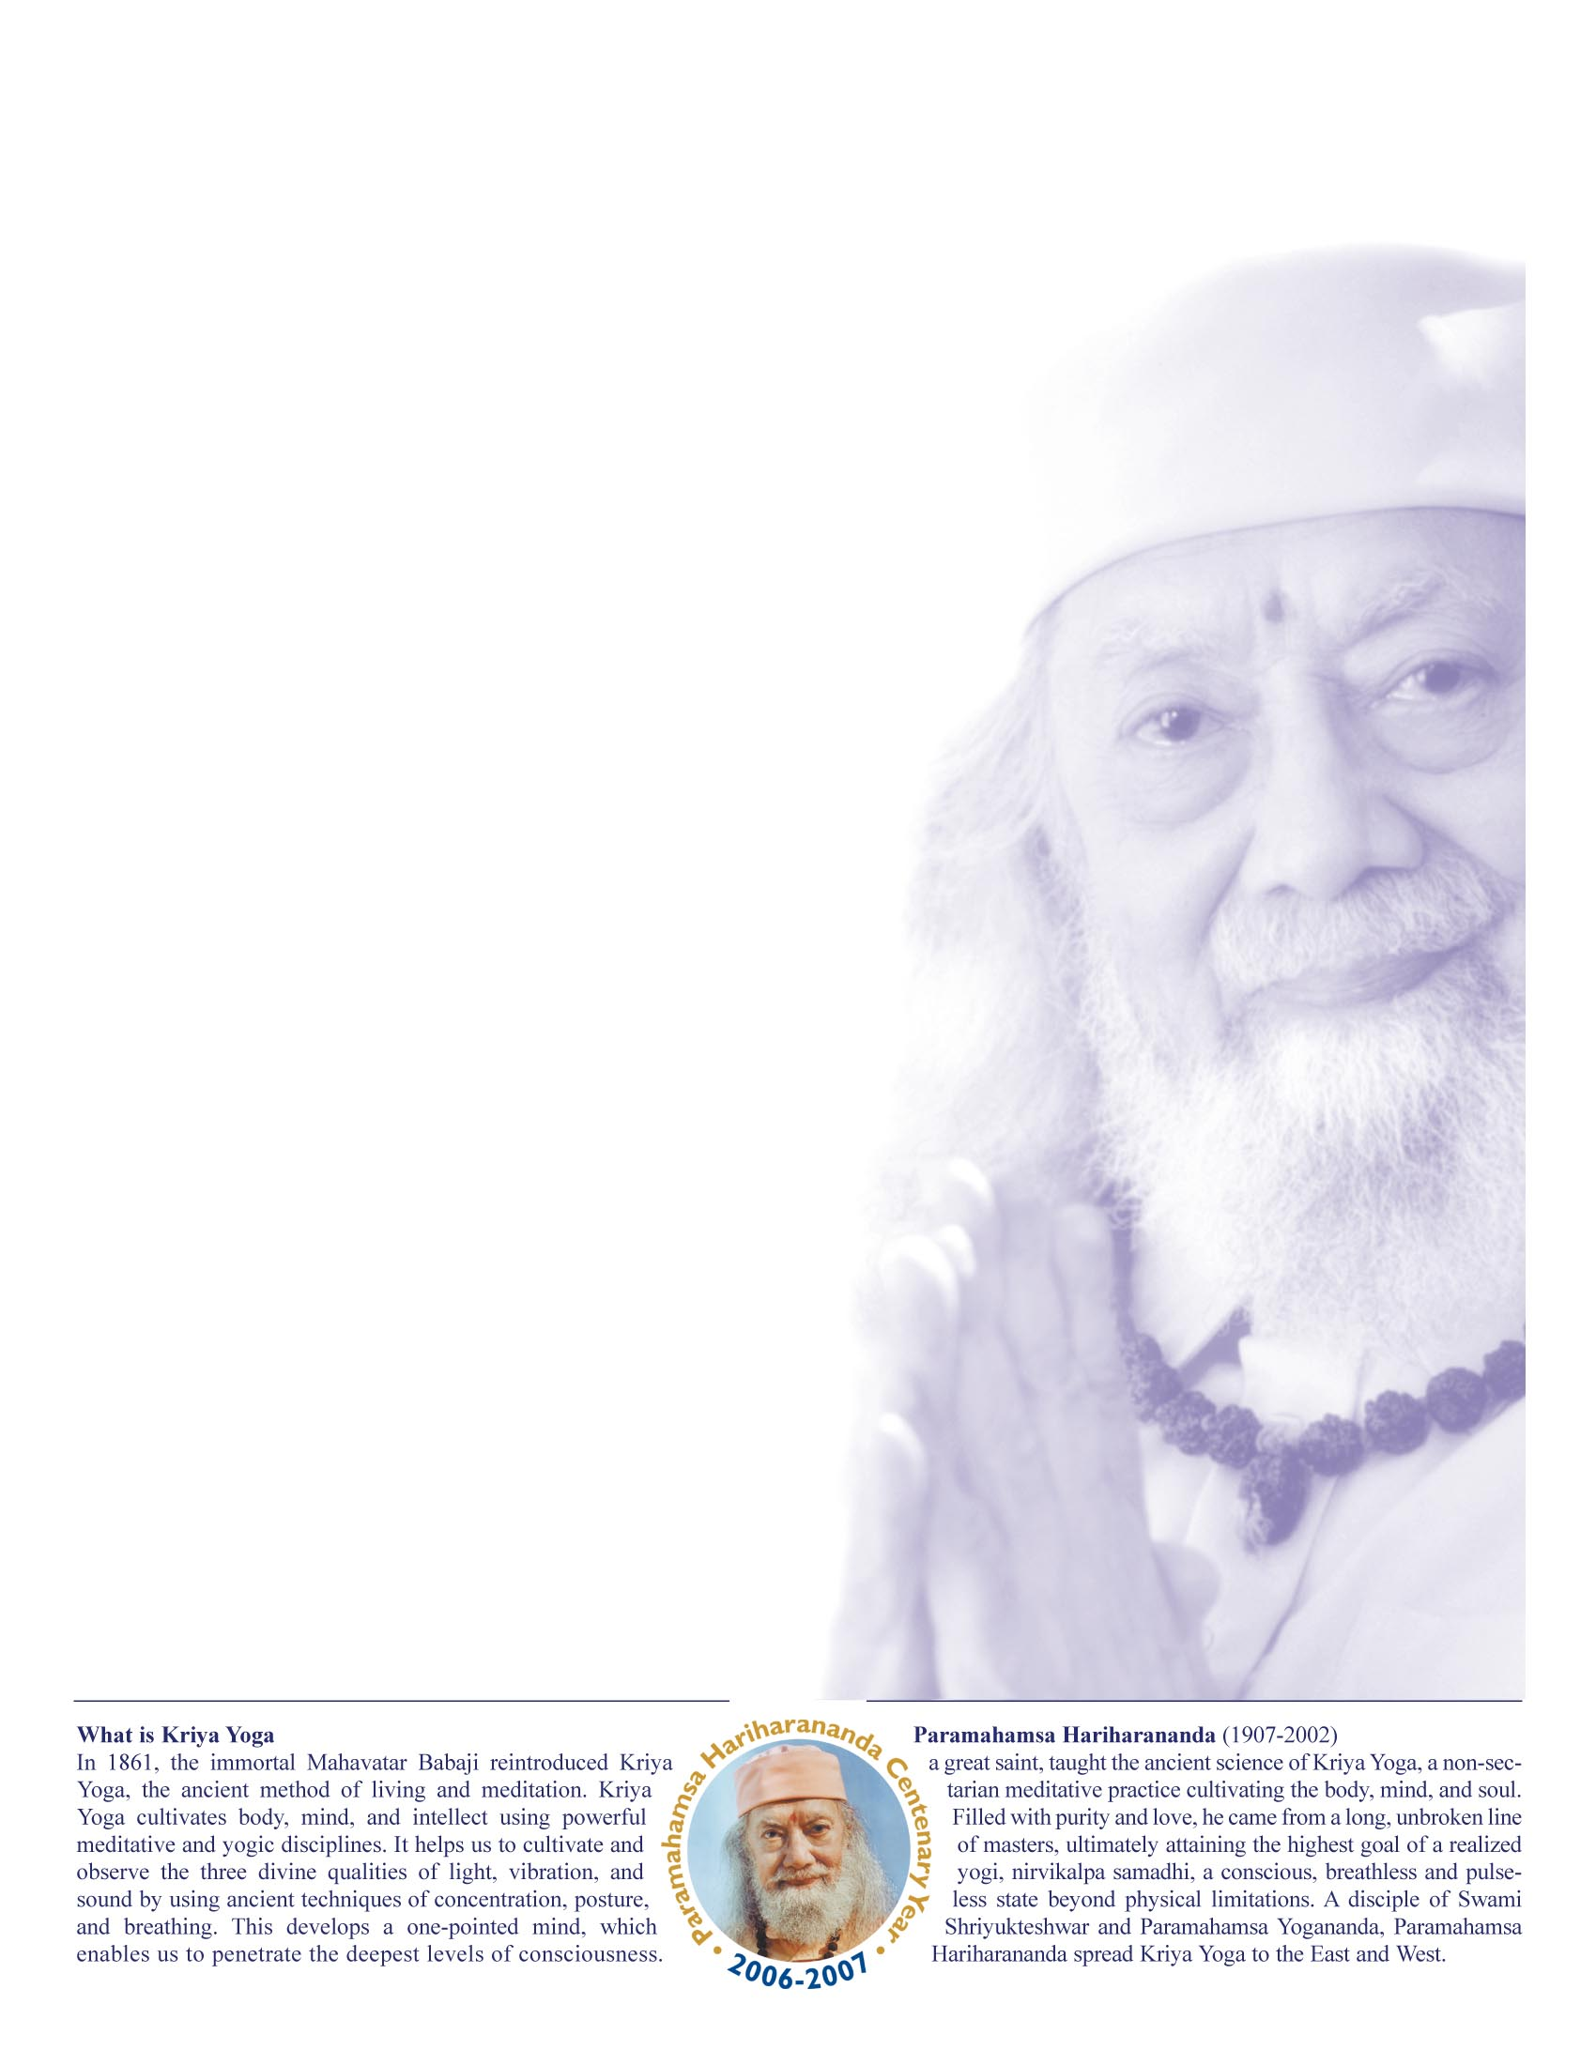

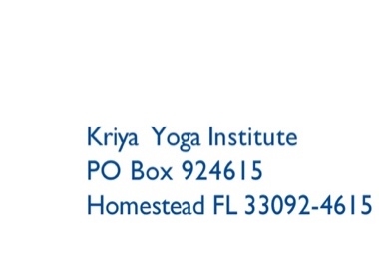

the loving teachings of
KRIYA YOGA

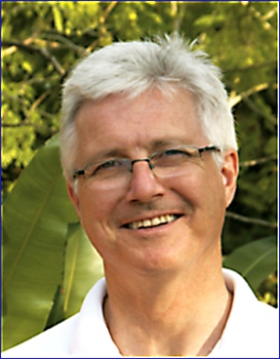
PUBLIC LECTURE - Kriya Yoga, Path to Inner Peace
Friday, Oct 24 7:00-8:15 pm
Rockpointe Clubhouse
22350 Devonshire Blvd, Chatsworth, CA, 91311

INITIATION PROGRAM
Rockpointe Clubhouse
22350 Devonshire Blvd, Chatsworth, CA, 91311
Saturday, Oct 25 09:00-12:30 pm– Initiation
12:30-02:00 pm – Lunch
02:00–05:00 pm – Practice
Sunday, Oct 26 09:00-12:30 pm– Practice
12:30–02:00 pm – Lunch
02:00–05:00 pm – Practice
Contact: Marydale Pecora 818 203-3377, info@losangeles.kriya.org

With Yogacharya Richard Peterson

Chatsworth, CA
October 24, 25 & 26, 2025

