Kriya Yoga In st itute O PO Box 924615 O Homestead FL 330 92-46150
+1 305-247-1960 0 institute@k riya .org 0 www.kriya.org

Kriya Yoga Int ensive
for Kriya Init iat es Only

Sunday, March _{15,} ₂₀₂₆
9:00 AM - 4:30 PM

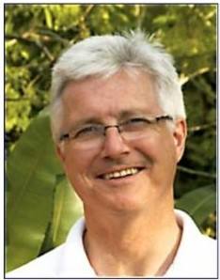

withYogacharya Richard Peterson

Schedule
9:00 to 10:30 am Meditation
10:30 to 10:45 am Break
10:45 to 11:45 am Discourse
11:45 to 11:50 am Break
11:50 am to 12:30 pm Q&A
12:30 to 2:00 pm Lunch
2:00 to 2:45 pm Discourse
2:45 to 3:00 pm Break
3:00 to 4:30 pm Meditation

Location Rockpointe Clubhouse 22300 Devonshire Street
Chatsworth, CA, 91311

Contact
Marydale Pecora at 818 203-3377
info@losangeles.kriya.org

SAVE THE DATE



This is a divine opportunity for Kriya Initiates to go deeper into meditation practice. Intensive includes meditation, technique review, Q&A, and discourse.



Please arrive early to sign in and register.

There is a registration fee of $40 (lunch is included). Bring your yoga mat, a bolster, water, and/or anything else you need to feel comfortable. There are chairs available. If you need directions, feel free to call or text:
818 203-3377.

